**Project Title:- Performance Enhancement by Beam-forming in Visible Light Communication For Multiple Users**

**M.N.K.M Bandara (Reg. No.21UG0496) & S.M.S.M Bandara (Reg. No. 21ug0496)**

**Supervisor: DR. Dilanka de Silva**

**Problem Statement:**

In traditional visible light communication (VLC) systems, the performance is often limited by fixed transmitter angles, leading to suboptimal data transmission for users located at different positions within a room. This project addresses this challenge by developing an adaptive transmitter system capable of dynamically adjusting its transmitting angle to optimize data transmission for multiple users simultaneously.

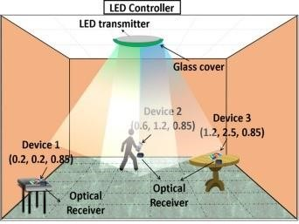

**References**

1. S.-M. K. Sung-Man Kim*, "Performance Improvement of Visible Light communications using beamforming," p. 4, 2013.
2. M.-W. B. a. S. H. N. Sung-Man Kim, "Visible light communication using TDMA optical beamforming," p. 6, 2017.
3. M. T. I.-L. C. M. J. M. I. V. E. . L. Vidal, B., “Simplified wdm optical beamforming network for large antenna arrays,” in IEEE Photonics Technology Letters, 2006.
4. A. M. Hussein, AT and M. Elmirghani, “Fast and efficient adaptation techniques for visible light communication systems,” in IEEE/OSA Journal of Optical Communications and Networking. [online]. Available: https://doi.org/10.1364/JOCN.8.000382, 2016

**Solution, Research, Methodology:**

Dynamic Transmitter Angle Adjustment: Utilize sensors such as photodiodes to detect the positions of users within the room. Based on this information, employ algorithms to calculate the optimal transmitting angles for the VLC transmitter to maximize signal strength and minimize interference.

User Position Tracking: Implement algorithms for real-time tracking of user positions, considering factors such as movement and orientation changes, to ensure continuous adaptation of the transmitter angle for optimal communication.

